

HELP GUIDE

IT ADMINISTRATOR

Login Page

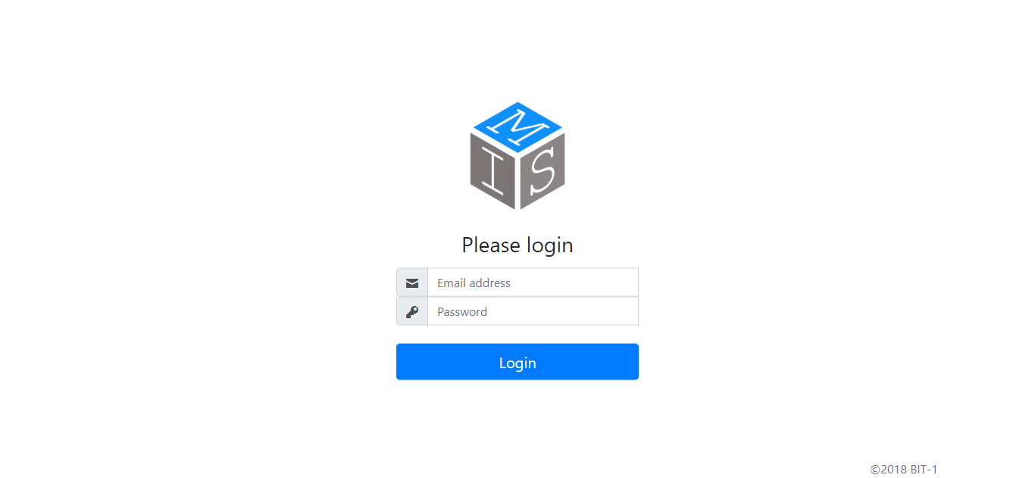

3.Press Login once e-mail, and password has been entered correctly.

2.Enter personal password.

1.Enter business e-mail address.

Dashboard

5.To get redirected to the page that will allow you to change your personal details.

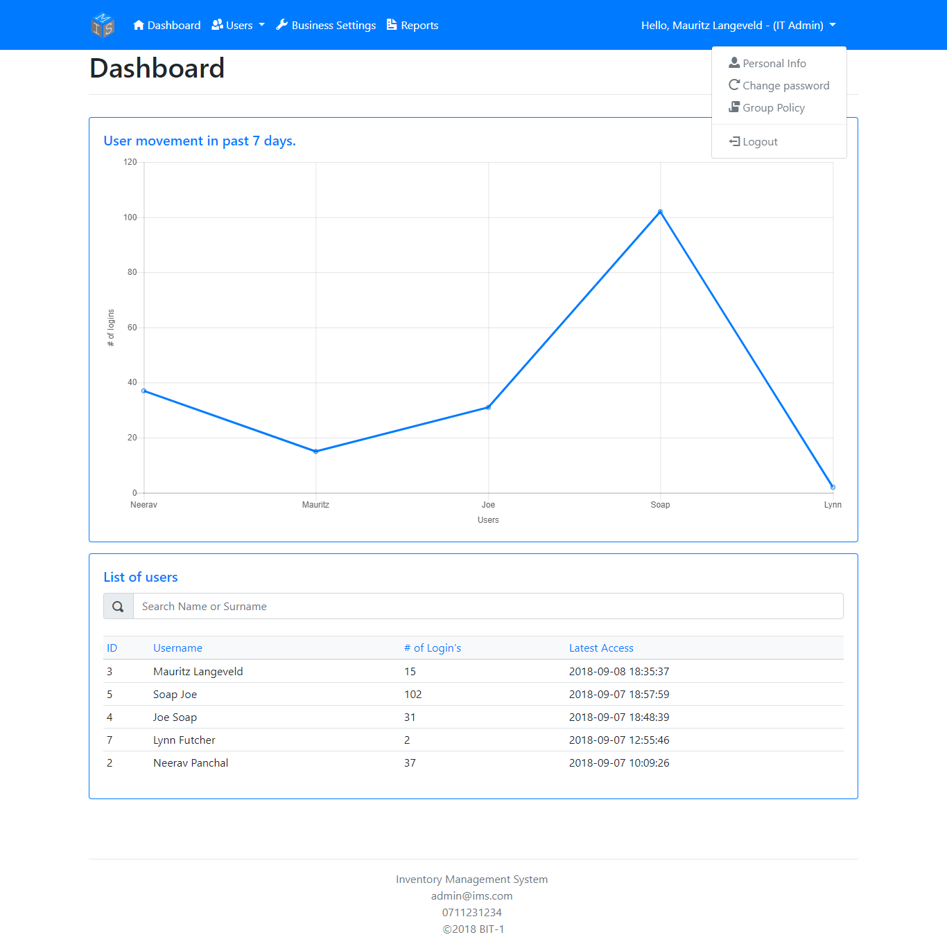

6.A PDF involving the business’s Group Policy will get downloaded onto your device.

4.To get redirected to the page that will allow you to reset your password.

2.Select a user whose access history you’d want to observe.

1.Enter a user’s Name and/or surname to filter the grid below.

3.(Behind logout) Press ‘Filter’ to filter a selected user’s (*see 2*) movement the last 7, 14, or 30 days. Press ‘Reset’ to return to default.

Manage Users

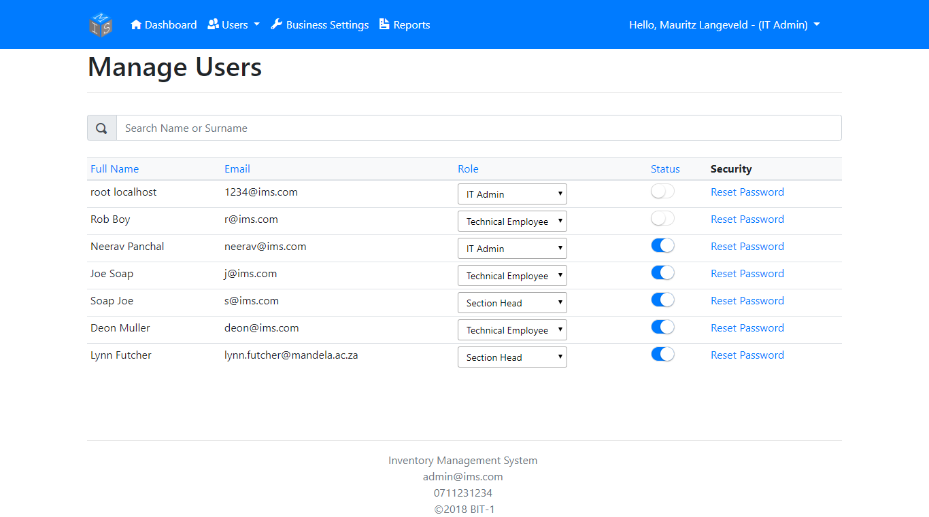

1.Enter a user’s Name and/or surname to filter the grid below.

3.Click on the switch to allow/disallow a user from using the system.

2.To change the user’s role (privileges) on the system, select a role from the dropdown list.

4.Click on ‘Reset Password’ to get redirected to the Reset Password page.

Password Reset

The user whose password will get a reset.

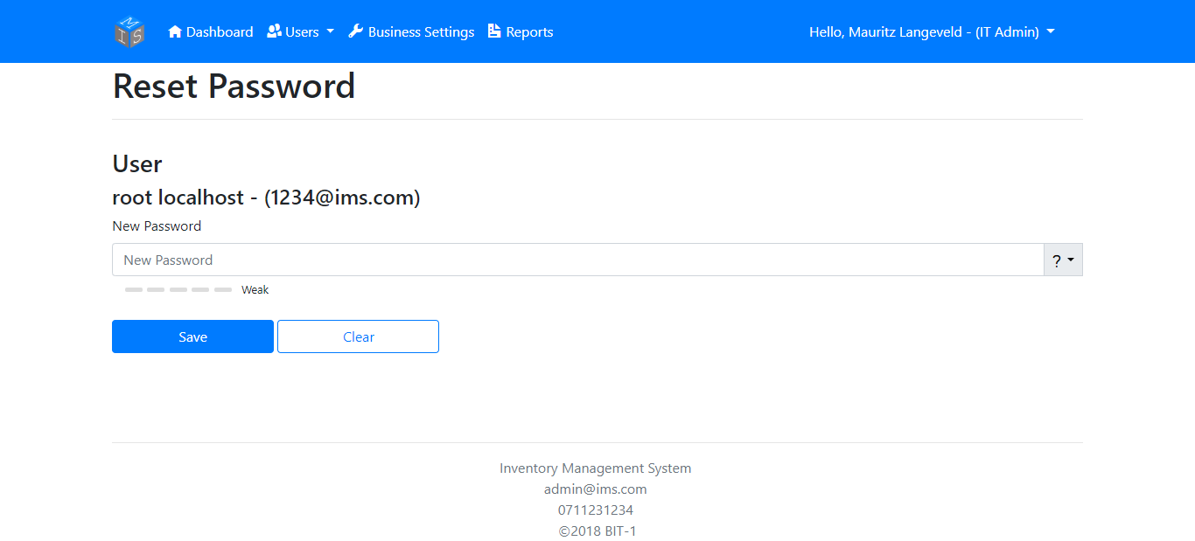

Enter the user’s new password. Mustn’t be less and 8 and more than 20 characters.

Show’s the strength of the entered password.

Hints on improving the password’s strength.

To clear the password entered.

To save the entered password and password conditions have been met.

Creating a User

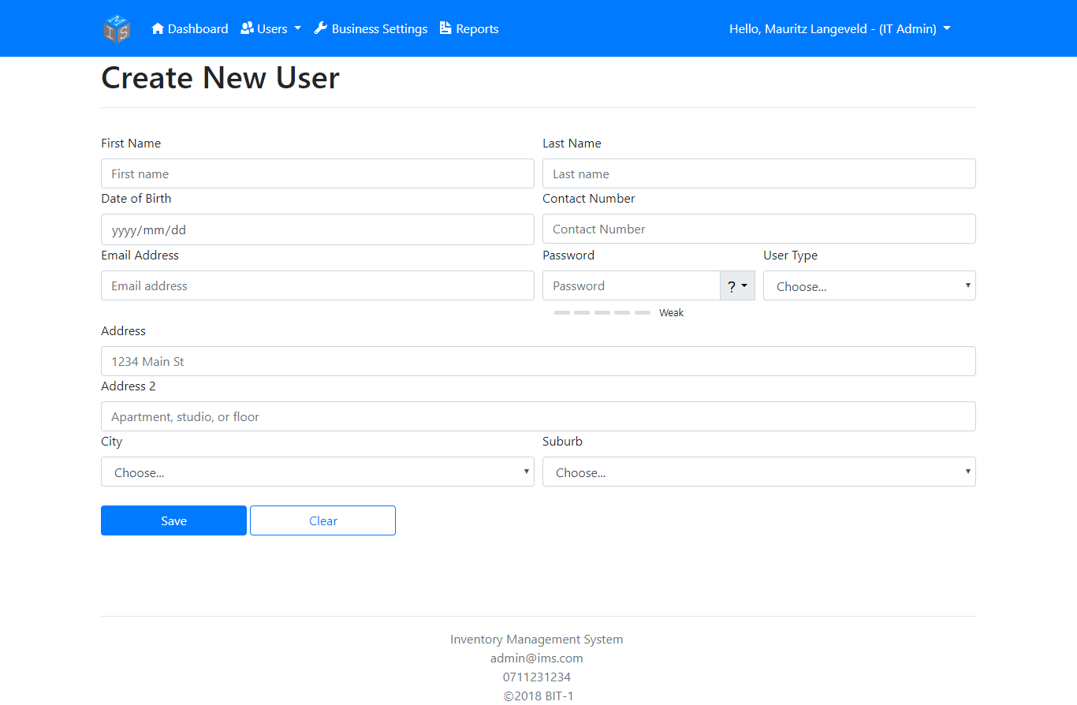

a. Suburb dropdown won’t load unless the user has selected a City.

b. If neither the new user’s City or their Suburb exist in the dropdown, press the ‘Add New City/Suburb’ selection located in the respected dropdown.

Click ‘Save’ to create the new user.

To clear all fields and revert all selections to default.

Update Personal Info

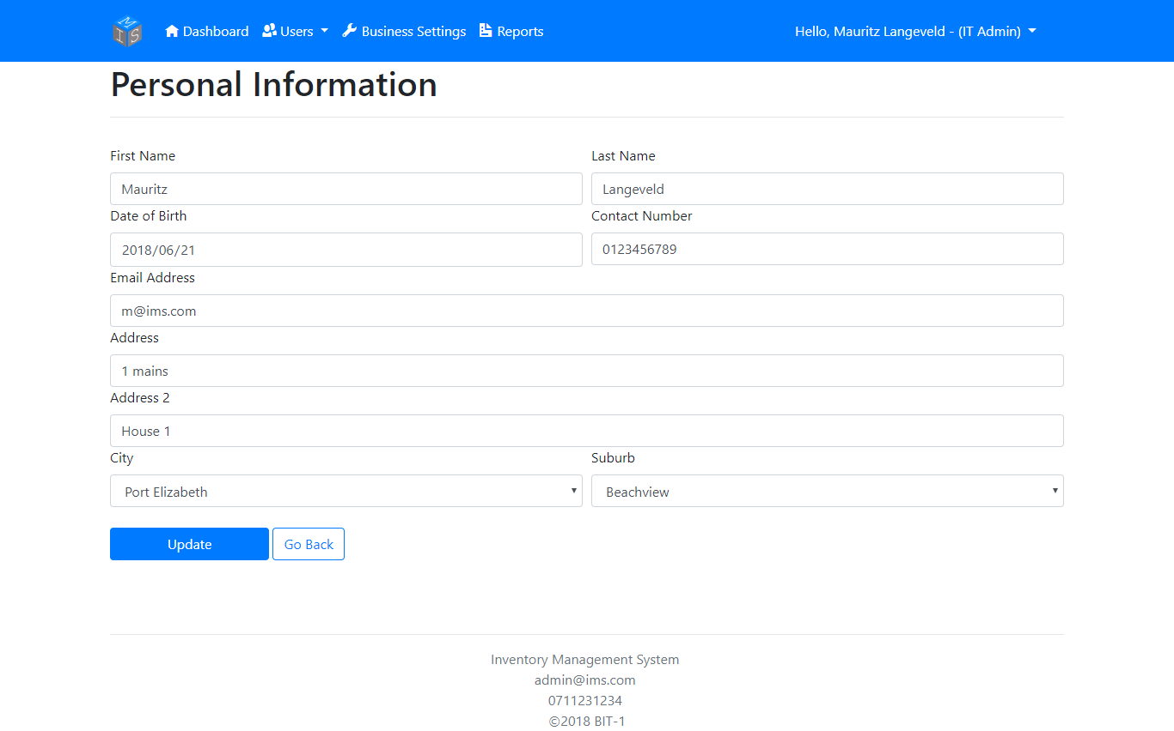

a. Suburb dropdown won’t load unless the user has selected a City.

b. If neither the new user’s City or their Suburb exist in the dropdown, press the ‘Add New City/Suburb’ selection located in the respected dropdown.

Click ‘Update’ to update your personal information.

Update Business Information

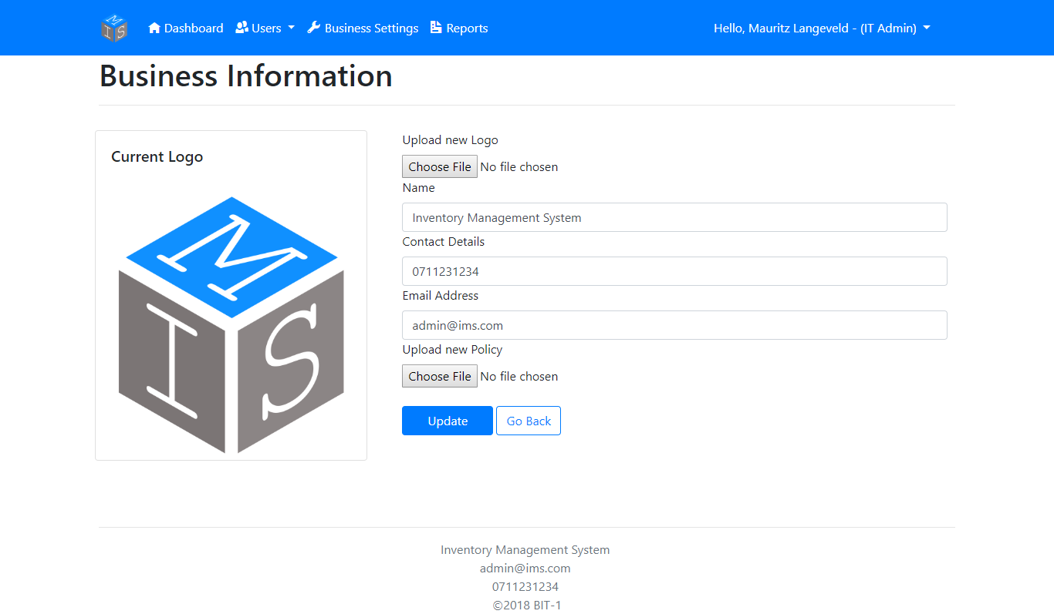

To select a new logo of the business.

To select a new policy file (PDF) of the business to upload.

To update new Business information.

Change Password

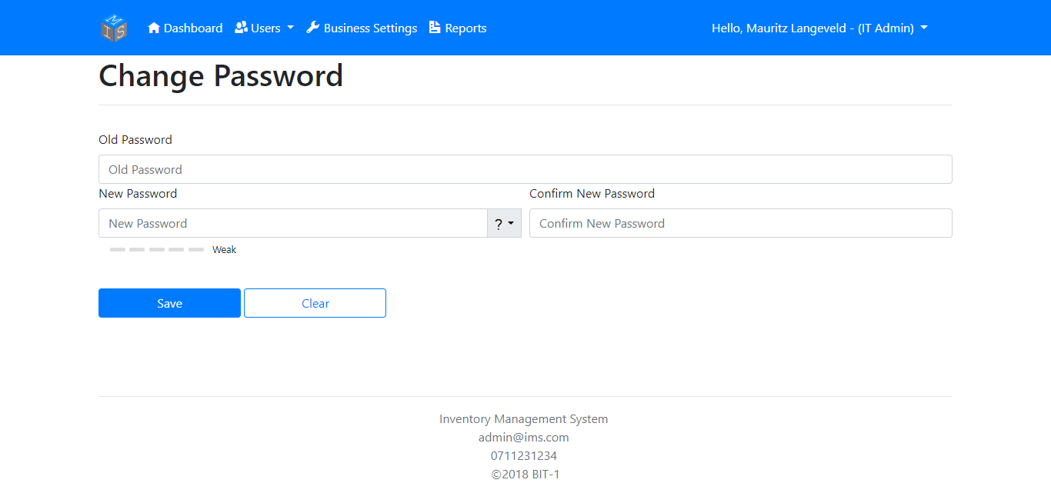

Enter your current password here…

Press ‘Save’ to change your password

Press ‘Clear’ to erase all fields.

Enter your new password here…

Re-enter your new password here…

Generate Reports

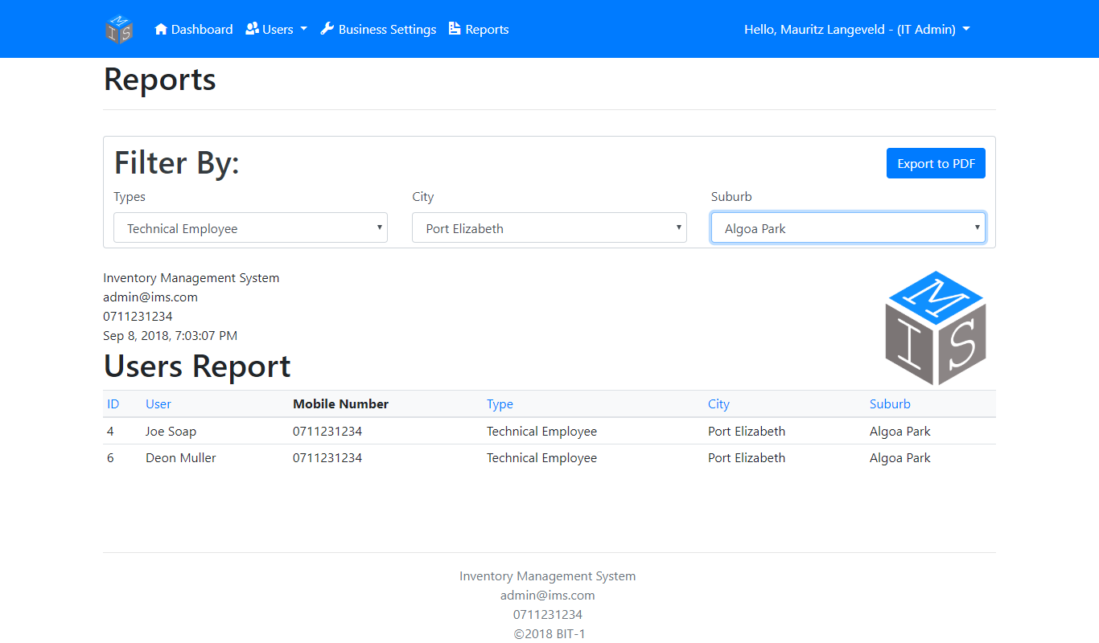

Export the report generated below to PDF.

Example report based on what the user filtered by.

Select the City to filter by.

Select the Suburb to filter by.

Select the type of user to filter by.